Observation and Recording Human Behavior in Interior Design: South Beach Hotel in Miami
Student’s Name
Institutional Affiliations

Observation and Recording Human Behavior in Interior Design: South Beach Hotel I Miami
Introduction
For this research, I selected a topic related to hospitality, a hotel to be precise. I visited South Beach hotel in Miami and recorded the information that I needed for my research. Miami South Beach hotel is located in the city of Miami Beach, Florida. The hotel provides a fresh and natural approach to customers who visit the place. Many tourists who come to Miami Beach are able to enjoy the elegant atmosphere surrounded by excellent interior designs. The hotel is within a walkable distance, and anyone from the Miami Beach or City can find his or her way to the South Beach hotel. The hotel was newly constructed but provides excellent services ranging from the serene environment to excellent interior designs in the rooms.
Methods
In this research, I collected data using direct observation. Even though observation is considered to be less reliable, it is also the best and more valid data collection techniques that one can use to collect qualitative data during research. I visited the hotel and took three hours directly observing the place. In my time there, I collected data through photographing and also note taking. The tools for these two methods include a camera and a notebook with a pen. I used a participant observation technique to get the finer appreciation and view of the hotel rooms. I directly observed the lighting of the rooms that I got the chance to visit and took the photos wherever I was allowed by the hotel management to do so. After collecting the relevant data that I required through note taking and photographing, I later compiled them after my visiting hours were over.
Observation Notes and Outcome
Research has shown that colour and light play a significant role in our lives because it affects our bodies and minds in different ways. My observation emphasized on the lighting of the rooms at the South Beach hotel in Miami. According to Ding and Guaralda (2013), effective use of light has been traditionally associated with aesthetic experiences in public places. I couldn't agree less with this statement; from my experience, I also noted the aesthetic experience that an observer or even those who visited the hotel could have from the visual perception of the rooms.
From my observation, I noted that all rooms in the hotel that I visited had different lighting. For instance, there were ambient, task lighting for those who want to work, and accent lighting. The interior designer at the hotel used the good down-lighting system effectively. For example, the rooms had large windows that enabled the rooms to get a fair amount of natural light from the sunlight during the day. Also, at night, the down-lighters provided a soft glow, as shown in the following photographs that added the ambiance in the rooms. From the observation of lighting, especially in the living rooms, I also noted some excellent wall lighting that provided a good experience. Wall lights are a good option for living rooms because it assists in setting the scenes that give a dazzling reflecting effect in the room when installed appropriately. As shown in the first image below, the room lighting on the wall did not provide too much or very little light, but when combined with the roof lights, the room was fantastic.
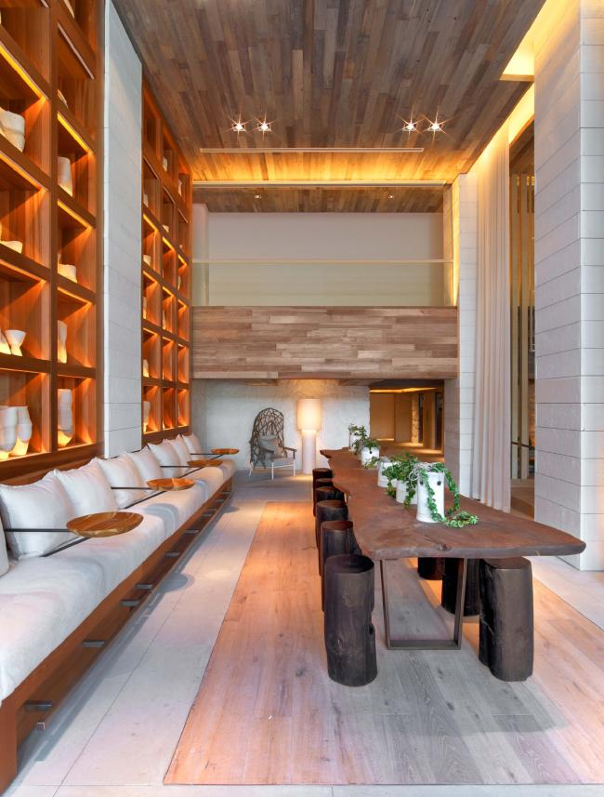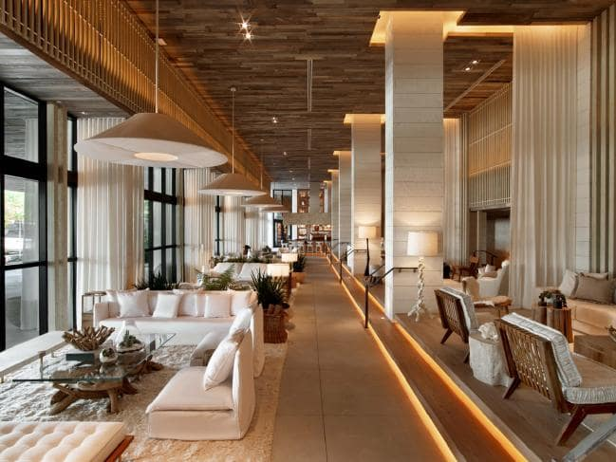
I also noticed that the lighting of the dining room was one of the most exquisite and important aspects of lighting in interior design. In the hotel, the lighting of the dining room was not only subtle but also sparkling. Featured with bright overhead lights fitted with chandeliers that are fitted with dimmer switches, the room was provided with sufficient on different occasions. Further, the lights of the dining room as shown in the following picture provided excellent roof scenes of the room.
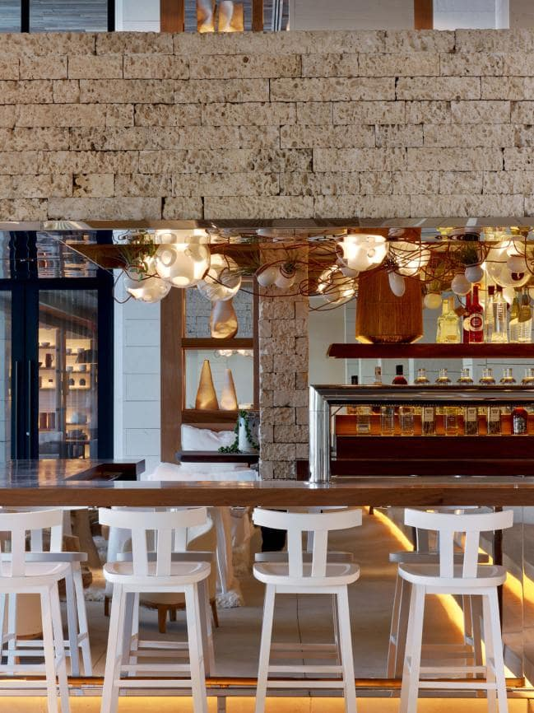
Suggestions
In terms of lighting, I would suggest that the interior of the living rooms could be fitted with table lamps. This is not because the room is not well lit, but because effective lighting is one way to improve and ass atmosphere to the room. Since the walls of both dining space and the living space are made of glasses mainly, fitting it with wall lights will add the dazzling experience for customers, especially at night.
Limitation
Even though the observation method, especially the participant technique was flexible, I also noted some limitation that could affect the outcome of my results. For instance, the method may affect the outcome due to lack of reliability. This is associated with the relativeness of the social phenomenon involved in the study and my personal biases as the observer could create difficulty for making a generalization about the rooms in the South Beach hotel. From the personal bias perspective, observation method may not be an appropriate method to obtain data and use it to make a generalization because everyone has a different way of interpreting and looking at things.
Conclusion
In conclusion, this research has highlighted and discussed lighting as one of the key aspects of interior designing as used in the South Beach hotel. Based on the participant direct observation method, I collected data through note taking and photographing which I used to compile this paper. Analysis of the outcome shows that lighting is one of the important aspects of interior design because it affects the way people see or perceive things.

Reference
Ding, Y., & Guaralda, M. (2013). The study of design elements and people’s behaviour in campus public space: how design shapes user’s behaviour. In_Bo Ricerche e progetti per il territorio, la cittá e l’architettura, 4(1), 114-136.

